Practical 12: Event Management CRUD with Poster Upload and File Validation
Problem Definition Develop event management functionality for admin users. Admin can add,
view, update, delete, and upload event posters with file type and file size
validation.

Theory :

Key Questions / Analysis / Interpretation
1. Are add, update, and delete functionalities implemented correctly?
Yes. Admin users can add new events, update existing event details, and delete events from the database.
2. Is the UI linked with the database correctly?
Yes. The user interface is connected to the MySQL database using PHP and MySQLi to store, retrieve, update, and delete event information.
3. Are poster uploads validated for type and size?
Yes. Poster uploads are validated to allow only permitted image file types and files within the specified size limit.
Implementation/out put/result:
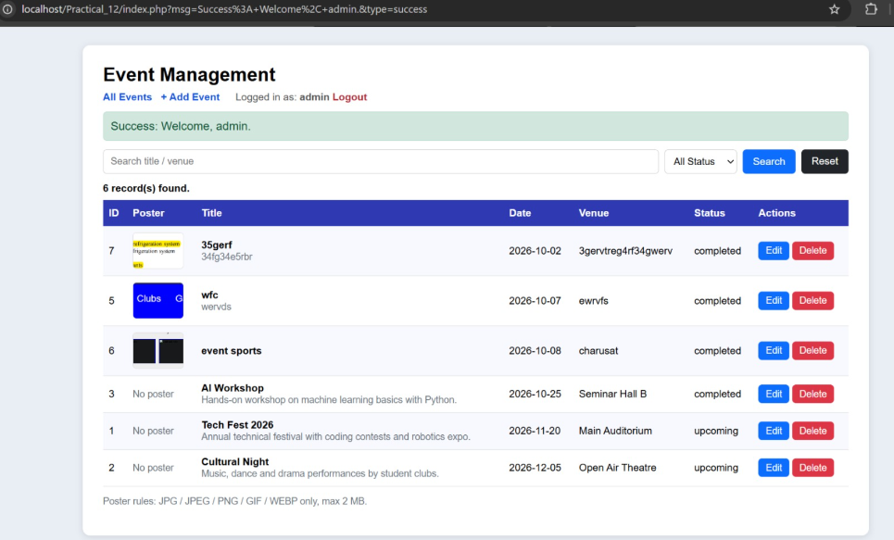

Git hub link:
https://github.com/Ayushsavaliya0305/25dce104-web

Learning outcomes:
Learned to perform add, view, update, and delete operations for event management.
Learned to connect the PHP interface with a MySQL database.
Learned to upload event posters using PHP.
Learned to validate poster file types and file sizes.
Learned to manage event details and posters securely.
Learned to display appropriate success and error messages.
Faculty remarks:

